Quarch Technology Ltd

Plugfest Hot-Plug

Instructions

For PCIe U.2 Drives ONLY

# 

# Setup

* 1. Copy the files provided on the USB stick to the host PC, ensure that there are NO spaces in the path name or folder you copy to
  2. Connect the Quarch module behind the drive to be tested and slide it carefully into the enclosure. See Simon Thomas at SerialCables if there is any doubt on doing this

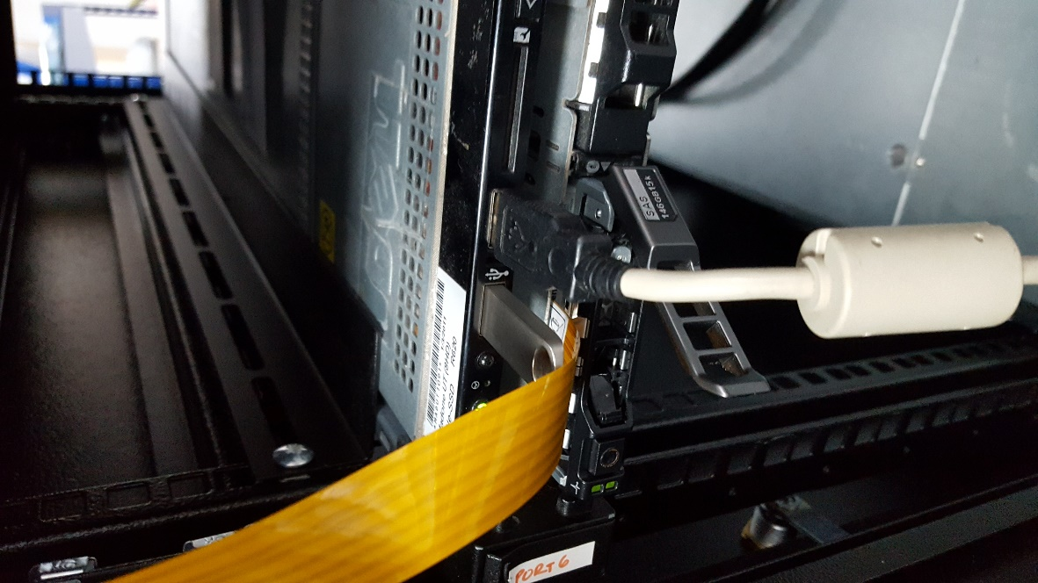

* 1. Connect the module to the while control box MAKE SURE the flex cable arrows are aligned.
     1. Connect USB to the host
     2. Make sure the button is pushed IN
     3. Connect the 12v power supply

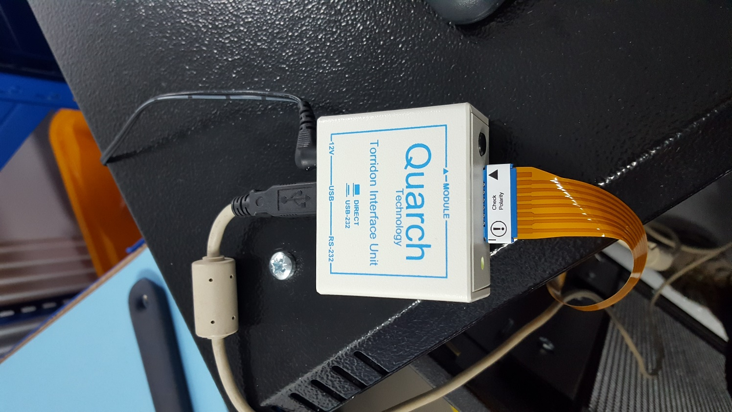

* 1. Check device manager to see the COM port created by the interface kit. If one is not created, you can download the FTDI driver from:  
     <http://www.ftdichip.com/Drivers/VCP.htm>
  2. Open an elevated Power shell terminal
     1. Click start menu
     2. Right click Power shell->Run as administrator

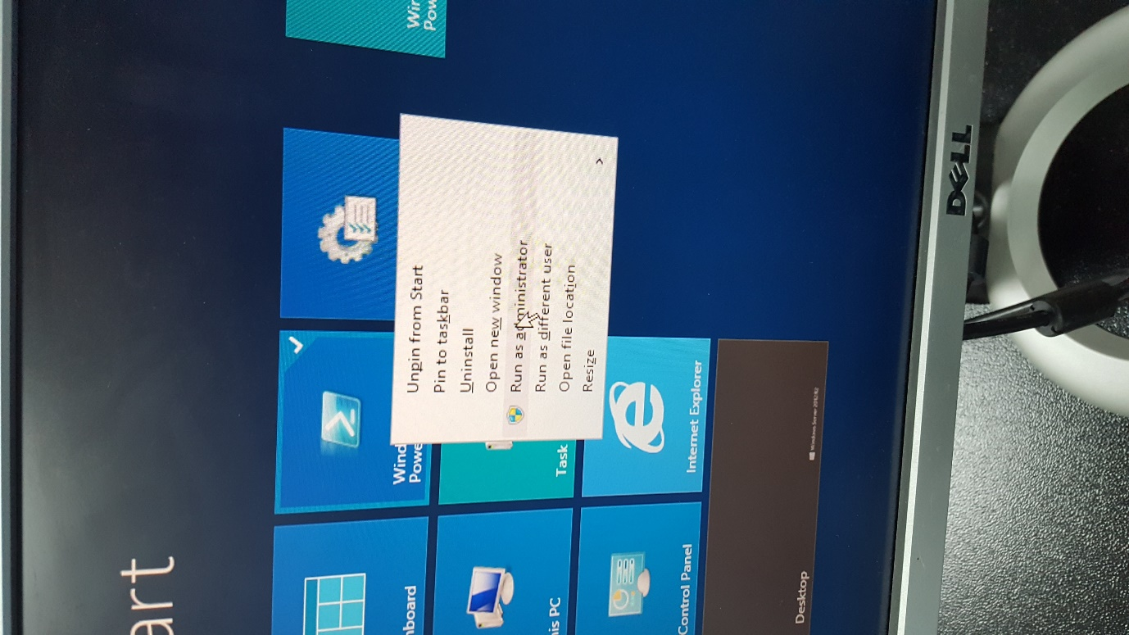

* 1. Navigate to the folder containing the files you copied in step 1

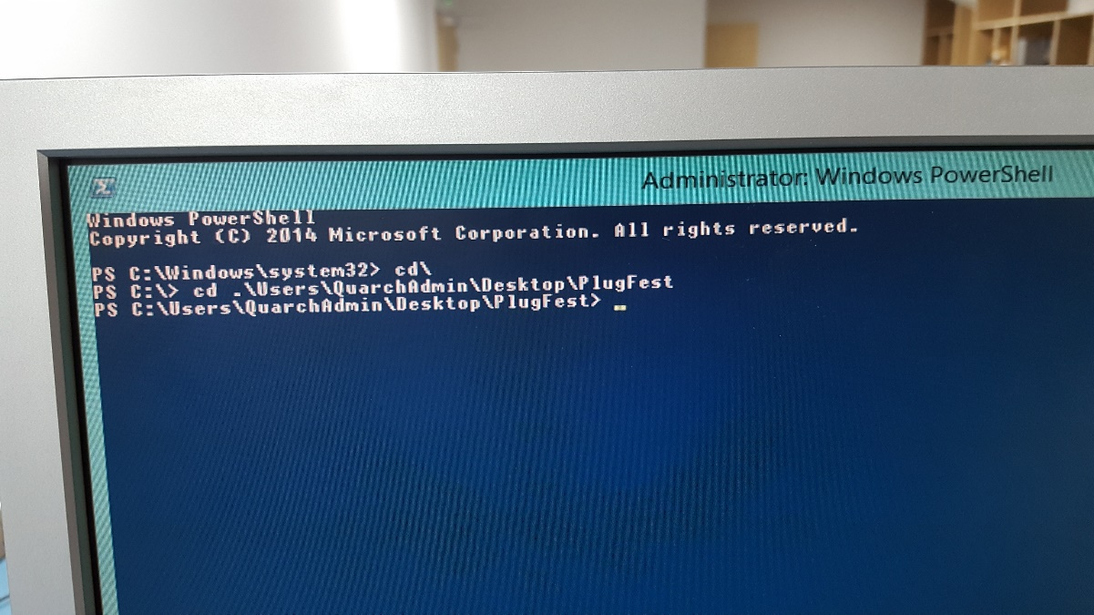

* 1. Run .\HotPlug.ps to begin the test

If you get a bunch of errors here, about the serial port being locked, Power shell may not have released it from the last test, close the power shell terminal and then re-open it again, as above. This can happen if you have previously run a test.

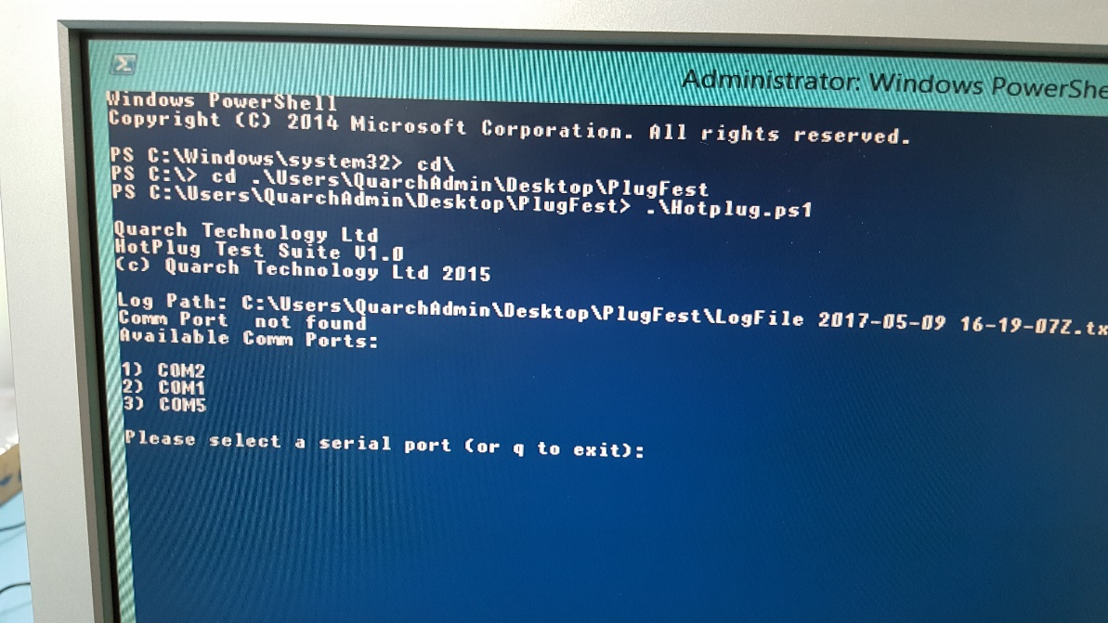

* 1. Select the COM port of the Quarch device by entering the index number and press enter, in this case 3, to select COM5

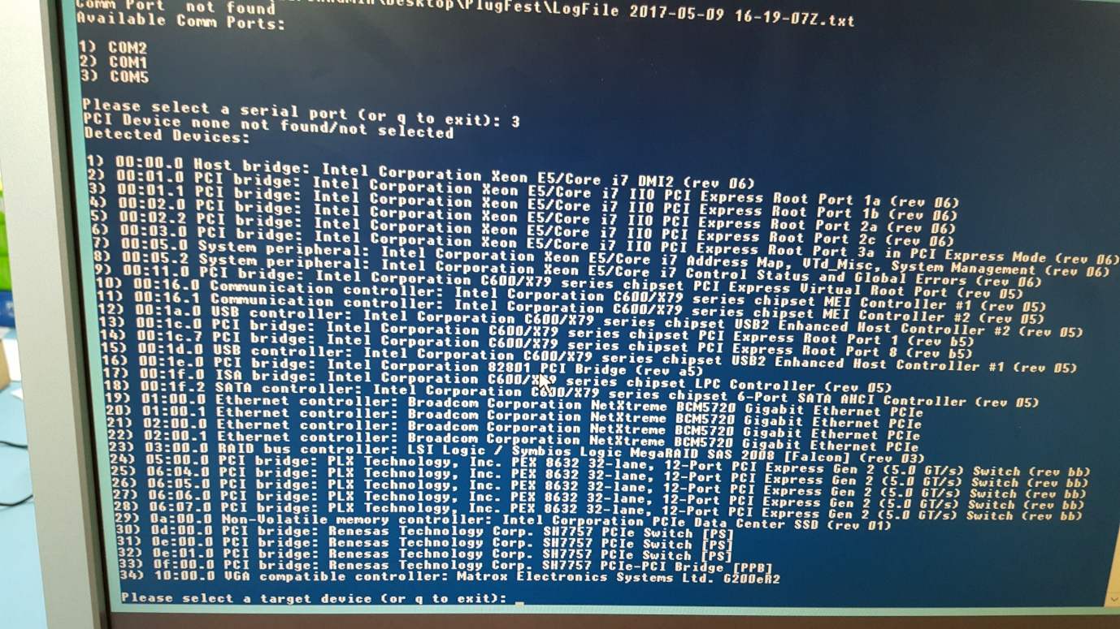

* 1. Now enter the ID number of your PCIe drive under test, 29 in this case to select the Intel SSD

If you do not see your device here, the Quarch module may be in ‘pulled’ mode. Use TestMonkey to ‘plug’ it, or cycle power on the white box to reset the module. This can happen if a test is halted part way through then you run another test.

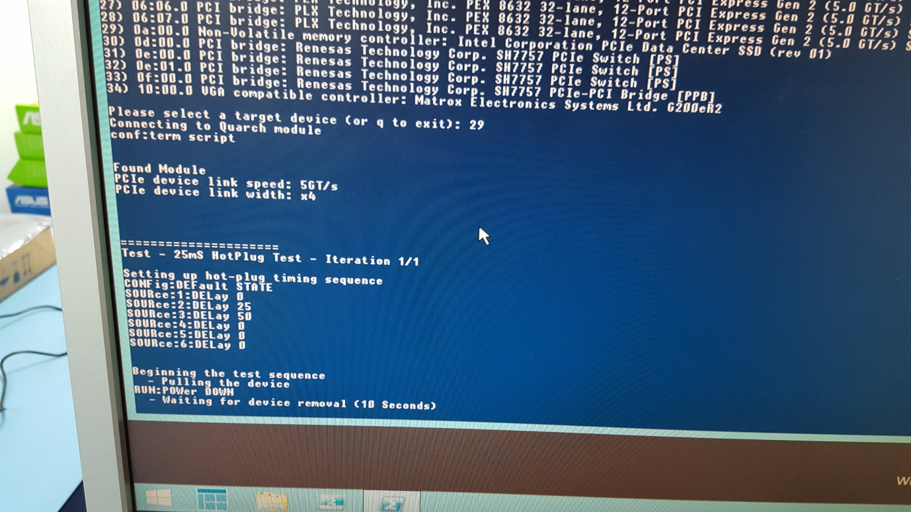

* 1. The test will now begin to run, note the link speed (5GT/s here) and link width (x4 here) at the start of the test, verify that this is what is expected of the drive under test.
  2. if there are any failures, the test will stop and a clear *** error message will be given

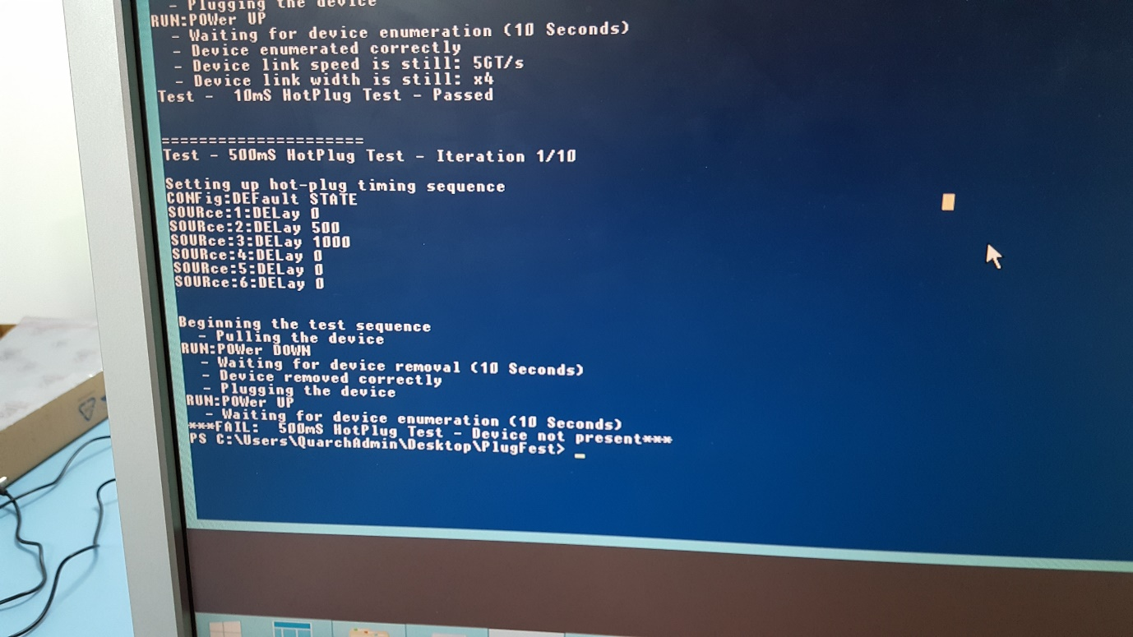

* 1. When complete, a full log file will be created in the root test folder, with a timestamp. Rename this to indicate the device being tested and store it with the results.